**MIS 6326.501 – Data Management - Assignment 3**

Swetha Krishnakumar (sxk151530)

**Complete the two Normalization problems below (A & B). The final product must be your own work. In your solution, show the Initial Grouping, 1NF, Dependency Diagram, 2NF, and 3NF. When appropriate, be sure to identify all functional dependencies (both partial and transitive).**

**Part A: TRIP**

The table structure shown in below contains many unsatisfactory components and characteristics. For example, there are several multivalued attributes, naming conventions are violated, and some attributes are not atomic.

**Sample TRIP Records**

|  |  |  |  |  |
| --- | --- | --- | --- | --- |
| **Attribute Name** | **Sample Value** | **Sample Value** | **Sample Value** | **Sample Value** |
| TRIP | 1003 | 1018 | 1019 | 1023 |
| DATE | 15-Jan-2008 | 15-Jan-2008 | 16-Jan-2008 | 17-Jan-2008 |
| CITY | STL | MIA | TYS | ATL |
| MILES | 580 | 1,290 | 524 | 768 |
| CUST_NUM | 10232 | 10233 | 10234 | 10235 |
| CUST_LNAME | Brown | Hanson | Bryana | Brown |
| PASSANGERS | 5 | 12 | 2 | 5 |
| CARGO | 235 lbs. | 18,940 lbs. | 348 lbs. | 155 lbs. |
| PILOT | Smith | Chen | Henderson | Smith |
| COPILOT |  | Henderson | Smith |  |
| FLT_ENGINEER |  | O’Shaski |  |  |
| LOAD_MASTER |  | Davis |  |  |
| AC_NUMBER | 1234Q | 3456Y | 1234Q | 2256W |
| PLANE_CODE | PA31-350 | CV-580 | PA31-350 | PA31-350 |
| PLANE_SEATS | 10 | 38 | 10 | 10 |
| PLANE_CHG_MILE | $2.79 | $23.36 | $2.79 | $2.79 |

1. **Write the relational schema and list the dependencies for the table structure. Make sure that you label all dependencies. The CHAR_MILES entry is based on round-trip miles, including pickup points. (Hint: Look at the data values to determine the nature of the relationships. For example, note that employee Smith has flown two charter trips as pilot and one trip as copilot.) (10 points)**

*See example on the last page on how to write this.*

Solution:

**Relational schema**:

**CHARTER** (**CHAR_TRIP**, CHAR_DATE, CHAR_CITY, CHAR_MILES, CUST_NUM, CUST_LNAME, FLT_PASSENGERS, CHAR_CARGO, EMP_PILOT, EMP_COPILOT, FLT_ENGINEER, LOAD_MASTER, AC_NUMBER, PLANE_CODE, PLANE_SEATS, PLANE_CHG_MILE)

**Primary Key: CHAR_ID**

**Dependencies**:

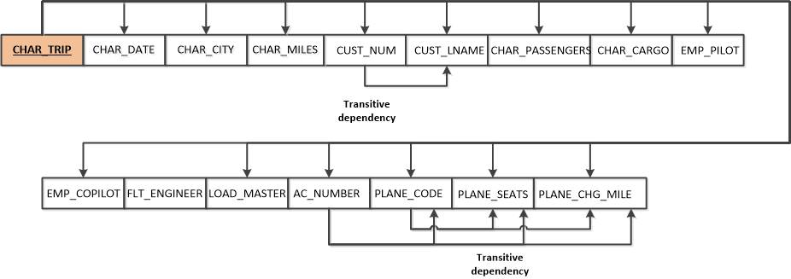

**Partial Dependencies:**

No partial dependencies

**Transitive Dependencies:**

CUST_NUM -> CUST_LNAME

AC_NUMBER -> PLANE_CODE, PLANE_SEATS, PLANE_CHG_MILE

PLANE_CODE -> PLANE_SEATS, PLANE_CHG_MILE

1. **Convert the relation to 3NF. (*Hint*: You might have to create a few new attributes. Also make sure that the new dependency diagrams contain attributes that meet proper design criteria; that is, make sure there are no multivalued attributes and that the naming conventions are met.) Write the corresponding relational schemas. Identify each primary key and each foreign key. (10 points)**

Solution:



|  |  |  |
| --- | --- | --- |
| **ENTITY NAME** | **PRIMARY KEY** | **FOREIGN KEY** |
| CHARTER | CHAR_TRIP | CUST_NUM,FLT_ID,LOAD_ID,AC_NUMBER |
| FLIGHT | FLT_ID |  |
| CUSTOMER | CUST_NUM |  |
| EMPLOYEE | EMP_ID |  |
| AC | AC_NUMBER | PLANE_CODE |
| PLANE | PLANE_CODE |  |
| CHARTER_EMPLOYEE | EMP_ID,CHAR_ID | EMP_ID,CHAR_ID |
| LOAD | LOAD_ID |  |

1. **Draw the ER Diagram. (5 points)**

Solution:

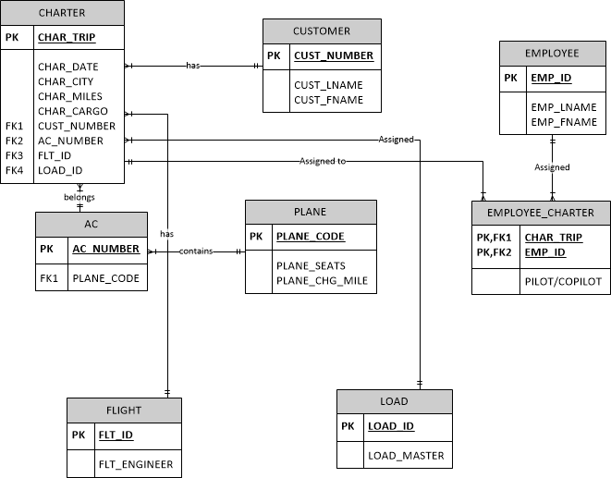

**Part B: WAREHOUSE**

The warehouse database stores inventory information. A warehouse has one manager who has an employee number (unique) and a name. A warehouse is identified by its warehouse name (unique) and its address. Every part in the warehouse has a part number (unique), inventory date, quantity-on-hand, supplier name (one), and the delivery number, data, and quantity. One delivery could deliver several parts. The database is shown below:

**WAREHOUSE** (manager-id, manager-name, warehouse-name, warehouse-address, part-no, inventory-date, qty-on-hand, supplier-name, delivery-no, delivery-date, delivery-qty)

1. **List the primary key(s) and list all transitive and/or partial dependencies in the relational schema diagram provided. (10 points)**

*See example on the last page on how to write this.*

Solution:

**Primary Key**: Manager_ID, Warehouse_Name, Part_No

**Dependencies**:



**Partial Dependencies:**

**MANAGER_ID** ->MANAGER_NAME

**WAREHOUSE_NAME** -> WAREHOUSE_ADDRESS

**PART_NO**->INVENTORY_DATE, QUANTITY-ON-HAND, SUPPLIER_NAME, DELIVERY_NO, DELIVERY_DATE, DELIVERY_QTY

**Transitive Dependencies:**

DELIVERY_NO -> DELIVERY_DATE, DELIVERY_QTY

1. **Convert the relation to 3NF. (*Hint*: You might have to create a few new attributes. Also make sure that the new dependency diagrams contain attributes that meet proper design criteria; that is, make sure there are no multivalued attributes and that the naming conventions are met.) Write the corresponding relational schemas. Identify each primary key and each foreign key. (10 points)**

Solution:

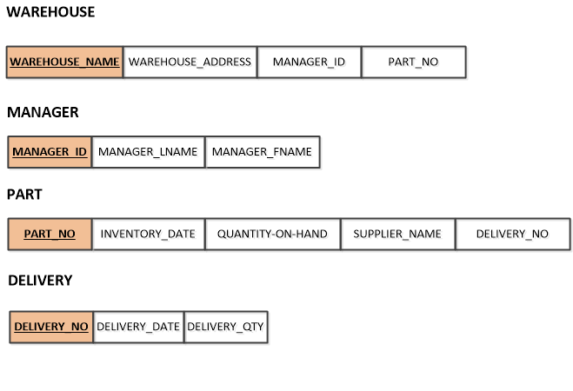

|  |  |  |
| --- | --- | --- |
| **ENTITY NAME** | **PRIMARY KEY** | **FOREIGN KEY** |
| WAREHOUSE | WAREHOUSE_NAME | MANAGER_ID,PART_NO |
| MANAGER | MANAGER_ID |  |
| PART | PART_NO | DELIVERY_NO |
| DELIVERY | DELIVERY_NO |  |

1. **Draw the ER Diagram. (5 points)**

Solution:

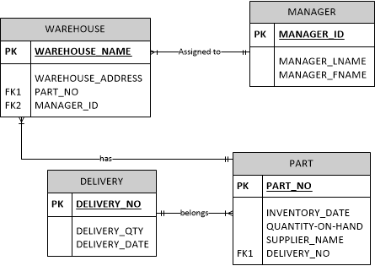

Example:

**Relational Schema**

EMPLOYEE(**EMP_CODE**, EMP_LNAME, EMP_EDUCATION, JOB_CLASS,

EMP_BASE_SALARY, EMP_COMMISSION_RATE)

The **dependencies** shown as:

EMP_CODE 🡪 emp_lname, emp_education, job_class….

**Partial Dependencies**

No Partial Dependencies

**Transitive Dependencies**

JOB_CLASS 🡪 emp_base_salary